“Київський фаховий коледж зв’язку”

Циклова комісія Комп’ютерної інженерії

**ЗВІТ ПО ВИКОНАННЮ**

**ЛАБОРАТОРНОЇ РОБОТИ №4**

з дисципліни: «Операційні системи»

**Тема: «Команди Linux для управління процесами»**

Виконавли студенти

групи РПЗ-03

Команда: Губенко Є.О.,

Заїка С.В. та Кресан Р.А.

Перевірив викладач

Сушанова В.С.

Київ 2022

**Мета роботи:**

1. Отримання практичних навиків роботи з командною оболонкою Bash.

2. Знайомство з базовими командами для управління процесами.

**Матеріальне забезпечення занять**

1. ЕОМ типу IBM PC.

2. ОС сімейства Windows (Windows 7).

3. Віртуальна машина – Virtual Box (Oracle).

4. Операційна система GNU/Linux – CentOS.

5. Сайт мережевої академії Cisco netacad.com та його онлайн курси по Linux

**Завдання для попередньої підготовки**

***Готував матеріал студент Губенко Є.О.***

1. На базі розглянутого матеріалу дайте відповіді на наступні питання:
   1. Які команди для моніторингу стану процесів ви знаєте. Як переглянути їх можливі параметри?

*There are many commands for monitoring the status of processes in different operating systems.*

*Here are some of them:*

1. **ps -** *this command displays information about processes running on the system. Some of the options that can be used with the ps command include -e (to display all processes), -f (to display full process information), and -u (to display processes that are running by a specific user).*
2. **top** *- this command provides a real-time view of the processes that consume the most resources. The command shows general statistics on the use of system resources such as CPU, memory, and disk space.*
3. **htop** *- is an improved version of the top command that provides additional features for monitoring processes, such as sorting by various criteria and the ability to check memory usage.*
4. **lsof** *- This command allows you to view the open file descriptors for the processes that are running. It can help you find processes that are taking up file resources and preventing them from being open to other processes.*
5. **iotop** *- This command allows you to monitor disk I/O operations in the system, which allows you to identify processes that consume more disk activity.*

*For each of these commands, there are additional parameters and options that can be used to display more detailed information about the processes. For more help with the parameters and options of any of these commands, you can use the man command, which provides complete documentation about the command and its capabilities. For example, to get documentation about the ps command, you can run the man ps command. You can also use the man pages with the -h or --help option to quickly get a list of available options and options that can be used with the command. For example, the ps --help command provides a summary of the available options for the ps command. In addition, you can use a variety of tools to monitor and analyze processes, such as sysstat, perf, strace, tcpdump, and others. These tools allow you to get more detailed information about processes and system resources, such as CPU, memory, disk space, network activity, etc. To use these tools, you can also use the documentation and tips that come with them.*

* 1. Чи може команда ps у реальному часі відслідковувати стан процесів?

*The ps command cannot monitor the state of processes in real time because it provides information about the state of processes at the time the command is run. You can use other tools, such as top, htop, or glances, to monitor the real-time status of processes.*

*The top command provides information about the state of processes in real time and allows you to track changes in this state in real time. To use the top command, open a terminal and enter the top command. Using the keys located on the keyboard, you can display various process parameters, change the sorting mode and filter processes by various criteria.*

*The htop command is an advanced alternative to the top command and provides additional information about the system status, such as memory and other resource usage. To use the htop command, you also need to open a terminal and enter the htop command.*

*The glances command is another tool for monitoring system and process status in real time. It provides additional information about network resource utilization and other parameters. To use the glances command, you also need to open a terminal and enter the glances command.*

* 1. За якими параметрами можливе сортування процесів в команді top? Як переключатись між ними?

*The top command allows you to sort processes by various parameters. The main sorting parameters include:*

1. ***PID - process identifier***
2. ***USER - the name of the user who is running the process***
3. ***%CPU - percentage of processor utilization***
4. ***%MEM - percentage of memory usage***
5. ***TIME+ - total time of the process execution***
6. ***COMMAND - the name of the command or program being executed***

*You can use the following keys to switch between sorting options:*

1. ***F*** *- select the field to sort*
2. ***S*** *- change the sorting direction (from largest to smallest or vice versa)*
3. ***q*** *- exit the sorting mode*

*After selecting a field for sorting, you can use the arrows on the keyboard to move through the process table and view detailed information about each process.*

* 1. Які команди для завершення роботи процесів ви знаєте?

***kill*** *- This command is used to send a signal to a process with a specific process ID (PID) to stop it. For example, to kill a process with PID 1234, run the following command: kill 1234. If you want to stop процес примусово, можна додати опцію -9 (or -SIGKILL) command, which sends a signal to the process to stop working immediately and without the possibility of recovery.*

***pkill*** *- This command allows you to kill all processes with a specific command name or user who started them. For example, to kill all processes owned by the user bob, run pkill -u bob. If you want to kill processes with a specific name, you can use the -f (or --full) option and specify the full name of the process.*

***killall*** *- This command is similar to pkill, but allows you to kill all processes with a specific command name. For example, to kill all processes named firefox, run the killall firefox command.*

*It is worth noting that stopping a process can result in data loss, so it is recommended that you use these commands carefully. Before you terminate a process, you should make sure that it needs to be terminated and that the process is not performing any important operation, such as saving data or completing a transaction.*

**Хід роботи**

1. Початкова робота в CLI-режимі в Linux ОС сімейства Linux:
   1. Запустіть віртуальну машину VirtualBox, оберіть CentOS та запустіть її. Виконайте вхід в систему під користувачем: CentOS, пароль для входу: reverse (якщо виконуєте ЛР у 401 ауд.) та запустіть термінал.
   2. Запустіть віртуальну машину Ubuntu_PC (якщо виконуєте завдання ЛР через академію netacad)
   3. Запустіть свою операційну систему сімейства Linux (якщо працюєте на власному ПК та її встановили) та запустіть термінал.
2. Дайте відповіді на наступні питання:

* Як вивести вміст директорії /proc? Де вона знаходиться та для чого призначена? Охарактеризуйте інформацію про її вміст?

*The /proc directory is a virtual file system in Linux that contains information about processes and the system as a whole. It is located in the root directory / and is readable only by users with administrator (root) privileges.*

*To display the contents of the /proc directory, you can use the ls command with the -l option, which displays detailed information about each file in the directory. For example, ls -l /proc lists all the files and subdirectories in the /proc directory.*

*The information in the /proc directory is organized into separate files and subdirectories that contain information about processes, system status, kernel settings, and more.*

*For example:*

*/proc/cpuinfo contains information about the system's processors, such as their model, speed, and number of cores.*

*/proc/meminfo contains information about the system's RAM usage.*

*/proc/net contains information about network connections and the status of the network stack.*

*/proc/sys contains kernel system settings, such as networking, task scheduling, and more.In addition, the /proc directory has separate subdirectories with information about each process running on the system, in particular:*

*/proc/<PID>/status contains general information about the process, such as its name, status, priority, and other parameters.*

*/proc/<PID>/cmdline contains the command line used to start the process.*

*/proc/<PID>/stat contains detailed information about the process, such as its ID, status, CPU time, memory usage, and other parameters.*

* Як вивести інформацію про поточні сеанси користувачів. Якою командою це можна зробити?

*Information about current user sessions can be displayed using the who command. This command displays a list of current user sessions that are on the system.*

*In addition, the who command displays information about each session, including the user's name, the terminal they are on, the time they logged on, and other details.*

*In addition to the who command, you can also use the w command, which provides additional information about each session, such as CPU usage and load.*

* Які дії можна зробити в терміналі за допомогою комбінацій Ctrl + C, Ctrl + D та Ctrl + Z?

*The keyboard shortcuts Ctrl + C, Ctrl + D, and Ctrl + Z are quite common in the terminal, so the actions you can perform with these shortcuts vary depending on the specific situation and terminal settings.*

*So, the main possible actions with the key combinations Ctrl + C, Ctrl + D and Ctrl + Z in the terminal are as follows:*

*Ctrl + C - interrupts the execution of the current command or program in the terminal. This can be useful if the command does not respond or does not work correctly, or if you want to cancel the command.*

*Ctrl + D - ends data entry or calls the logout command to end the session in the terminal. This can be useful if you need to quickly finish working with the terminal or exit the terminal from the input standby mode.*

*Ctrl + Z - stops the execution of the current command or program and places it in the background. This can be useful if you need to execute several commands or programs at the same time. After a program has been placed in the background, you can return to it with the fg command.*

* Чим відрізняється фоновий процес від звичайного. Де вони використовуються?

*A background process is a process that runs in the background without interacting with the user of the terminal or other input device. A regular process, on the other hand, runs in an interactive mode, that is, it interacts with the user through the terminal or other input devices.*

*When a normal process starts, it blocks the terminal and waits for input from the user. At the same time, other processes cannot interact with the terminal until this process is completed. In the background, the process does not block the terminal and continues to run regardless of whether the user interacts with the terminal or not. Background processes are often used to perform long-term tasks, such as data processing, backup, file synchronization, etc.*

*To run a process in the background, you can add the ampersand character "&" after the command in the terminal. For example, the command ls -lR / > output.txt & will start the process of viewing the contents of the "/ " directory in the background and output the result to the file "output.txt". To view a list of background processes running on this terminal, you can use the jobs command. To return the background process to the active mode (foreground), you can use the fg command. To stop a background process, you can use the kill command, which will terminate the process.*

* Опишіть наступні команди та поясніть що вони виконують – команда jobs, bg, fg.

*The jobs, bg, fg commands are related to managing background processes in Unix-like operating systems.*

*jobs - this command displays a list of background processes that have been running on this terminal. Each background process has a unique identifier (job ID), which is used to interact with it using other commands.*

*bg - this command starts a stopped background process (a process that was suspended using the Ctrl-Z key combination or another command). The background process will continue its work in the background, that is, without blocking the terminal. If you call the bg command without parameters, the last paused background process will be launched. You can also specify the background process number (job ID) to start it.*

*fg - this command resumes the work of a suspended background process in the active mode (foreground). Thus, the process blocks the terminal again and waits for user interaction. If you call the fg command without parameters, the last stopped background process will be restored. You can also specify a background process number (job ID) to continue its operation in the foreground.*

*These commands allow you to control background processes running in the terminal, that is, to start them, switch them to the background, suspend them, and resume them in the active mode. They help users effectively manage the multitasking environment, which is important in Unix-like operating systems.*

* Якою командою можна переглянути інформацію про запущені в системи фонові процеси та задачі?

*To view information about background processes and tasks running in the system, you can use the jobs command. It displays a list of processes running in the background, as well as their numbers and status.*

*Example.:*

*[1]+ Running sleep 100 &*

*[2]- Stopped vim test.txt*

*In this example, you can see that the first process is in the Running state, its number is 1, and it is the sleep command that was run with the & option (running in the background). The second process is in the Stopped state, its number is 2, and it is the vim text editor process that was stopped with the key combination Ctrl+Z.*

*To bring the background process to the foreground, you can use the fg command, and to put the process in the background, use the bg command.*

* Як призупинити фоновий процес, як його потім відновити та при необхідності перезапусти?

*To pause a background process, you can use the keyboard shortcut Ctrl+Z. This combination will stop the process and switch it to the Stopped state.*

*To restore a paused process to the foreground, use the fg command, or restore it to the background using the bg command. If you need to restart a process, you should first stop it, and then execute the command to start the process again.*

*For example, to pause the background process numbered 1, enter the key combination*

*Ctrl+Z:*

*$ sleep 100 &*

*[1] 12345*

*$ ^Z*

*[1]+ Stopped sleep 100*

*Then, to bring the process back to the foreground, type fg:*

*$ fg %1*

*Or, to resume the process in the background:*

*$ bg %1*

*To restart a process, you must first execute the kill command to stop it, and then start the process again:*

*$ kill %1*

*$ sleep 120 &*

*[2] 23456*

1. Запустіть термінал, та в командному рядку виконайте наступні дії для ознайомлення з роботою з процесами:

* run the top command, analyze the result obtained in this command and characterize the most active processes in the system;

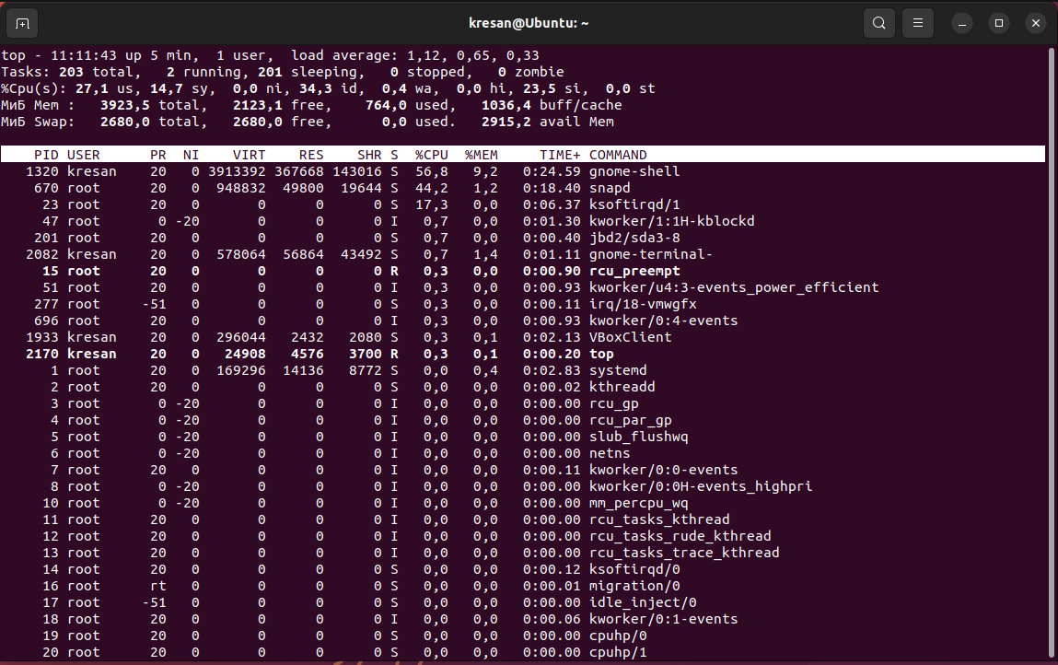

The top command allows you to monitor the status of processes in real time. After running the command, a table appears on the screen showing the most active processes in the system. The upper part of the table shows general statistics about the system, such as the total number of processes, system uptime, average CPU load, and other indicators.

The lower part of the table contains information about individual processes, including their PID, process name, user who started the process, percentage of CPU time used, memory used by the process, and other indicators.

The most active processes can be identified by the amount of CPU time (CPU%), memory (MEM%), input/output (I/O), etc. The most active processes usually have a high percentage of CPU time utilization or use a significant amount of memory.

For example, the following table shows the most active processes on the system at a given time:

**top - 11:30:45 up 10 days, 19:34, 1 user, load average: 0.22, 0.21, 0.22**

**Tasks: 372 total, 2 running, 370 sleeping, 0 stopped, 0 zombie**

**%Cpu(s): 1.8 us, 0.2 sy, 0.0 ni, 97.9 id, 0.0 wa, 0.0 hi, 0.0 si, 0.0 st**

**MiB Mem : 32185.2 total, 7125.3 free, 12299.9 used, 12760.0 buff/cache**

**MiB Swap: 0.0 total, 0.0 free, 0.0 used. 18639.2 avail Mem**

**PID USER PR NI VIRT RES SHR S %CPU %MEM TIME+ COMMAND**

**29551 user1 20 0 878560 278856 72504 S 3.0 0.8 139**

* pause the execution of the top command (use the key combination);

*To stop the top command, you need to enter the key combination CTRL+Z*

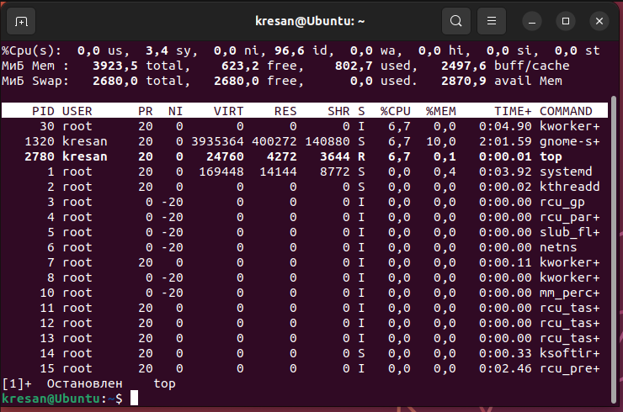

* display information about processes using the ps command;

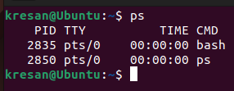

* - Give 5 examples using different parameters of the ps command (e.g., list only system processes, list processes of a specific user, list a process tree, etc.)

Describe what exactly the options you have selected do

|  |  |
| --- | --- |
|  | *Display a list of processes that are currently running in the system, including additional information about each process:*   * *a: display processes for all users, not just for the current user* * *u:* *display extended information about the user who started each process* * *x: display processes that are not related to the terminal* |
|  | *Print the list of processes that are currently running in the system, including the process tree:*   * *a: display processes for all users, not just for the current user* * *x: display processes that are not related to the terminal* * *f: display the process tree, showing parent and child processes* |
|  | *Print a list of processes that a particular user is currently running:*   * *-u kresan: display processes belonging to a user with a name "kresan"* |
|  | *-e: display the processes of all users*  *-: do not display the column header*  *grep firefox: the text to be found in the output of the ps command* |
|  | |
| *Print a list of processes displayed in a tree view with additional information about each process and sorted by memory usage:*   * *a: display processes for all users, not just for the current user* * *u: display extended information about the user who started each process* * *x: display processes that are not related to the terminal* * *f: display the process tree, showing parent and child processes*   *--sort=-%mem: sort by memory usage in reverse order (from largest to smallest)* | |

* передивіться чи є у Вас запущені фонові процеси, які саме?

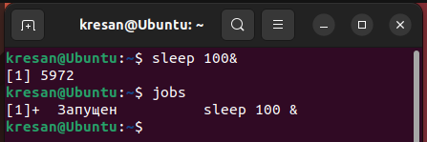

*First, we created the sleep background process, and then we used the jobs command to bring up all the running background processes.*

* - resume execution of the paused background process first in the foreground position, then pause it again, and then resume its execution in the background position)

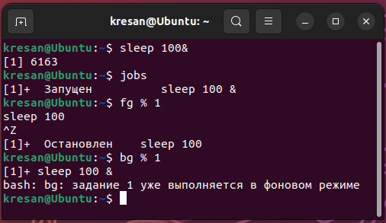

- terminate the work of this background process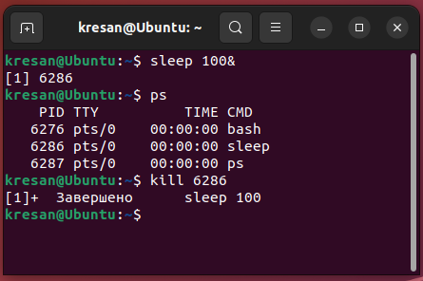

***Готував матеріл студент Заїка С.В.***

**Відповіді на контрольні запитання**

1. Яке призначення директорії /proc в системах Linux. Яку інформацію вона зберігає?

*The /proc directory on Linux systems contains a virtual file system that provides access to information about the current state of the system, processes, kernel, and hardware. It provides an interface for communication between the kernel and various processes.*

*The /proc directory contains files that represent the processes running on the system, detailed information about the current kernel subsystems (for example, processor, memory, file systems, and network), system parameters, and many other useful information.*

*These files can be used for debugging, monitoring, and customizing the system. For example, you can check the current state of the system, view detailed information about running processes, change system parameters, configure the network, etc..*

1. Як серед будь-яких трьох процесів динамічно визначати, який з них в поточний момент часу використовує найбільший обсяг пам’яті? Який відсоток пам’яті він споживає від загального обсягу?

*To determine the process that is using the most memory, you can use the "top" or "htop" command. These commands display information about the current processes, including memory usage.*

*To display processes in descending order of memory usage, press the "M" key. This will display a list of processes, starting with the one that uses the most memory.*

*To determine the percentage of memory that this process uses, you need to look at the "MEM%" column in the process table. This column shows the percentage of memory used by each process.*

*Thus, to dynamically determine the process that is currently using the most memory, you need to open a terminal and run the "top" or "htop" command. Then you need to sort the processes by memory usage and view the process that uses the most memory. The percentage of memory used by this process can be seen in the "MEM%" column.*

1. Як отримати ієрархію батьківських процесів в системах Linux? Наведіть її структуру та охарактеризуйте.

*The hierarchy of parent processes in Linux systems can be obtained using the "pstree" command. This command displays the hierarchy of processes in the form of a tree, where each process is displayed as a node, and its children are displayed as children of this node.*

*The structure of the parent process hierarchy can be as follows: - The system process PID=0 (sometimes called "swapper" or "scheduler") is the root of the process tree. This process is the parent of all other processes in the system.*

*- The first-level processes have PID=1 and are the "init" process, which is the parent of many other processes in the system. The "init" process is created by the kernel when the system boots.*

*- Children of the "init" process can be divided into groups, which can have their own parent processes.*

*- Processes can have their own children, which appear as children of this process in the process tree.*

*The hierarchy of parent processes can be characterized as follows:*

*- Every process on the system has a parent process, except for the process with PID=0.*

*- The Linux kernel creates the "init" process when the system boots, and it is the parent of many other processes.*

*- Each child process can have its own children, which forms a process tree.*

*- The hierarchy of parent processes allows you to control and manage processes in the system.*

*- The process tree can be used to determine the relationships between processes and to solve problems with memory and other resources.*

*- The hierarchy of parent processes also helps to ensure system security, as child processes cannot interact with parent processes without special permissions.*

*- Using the "pstree" command, you can display the process tree in a convenient form for analysis, which helps to understand the structure of processes in the system and their relationships.*

1. Чим відрізняється команда top від ps?

*The top and ps commands are both tools for monitoring processes in Linux systems, but they have some differences:*

*- Visualization: top displays information in the form of a live list that is automatically updated at intervals set by the user, while ps simply displays a list of processes at the current time.*

*- Detail: top provides detailed information about system resources, such as memory and CPU usage, while ps displays only basic information about processes.*

*- Functionality: top allows users to interact with processes, such as pausing and stopping processes, setting priorities, etc., while ps only provides information about processes.*

*- Sorting: top allows you to sort processes by various parameters such as CPU and memory usage, while ps sorts only by process ID and other basic parameters.*

*In general, top and ps are useful tools for monitoring processes on a system, but they have different functions and can be used for different purposes.*

1. Які додаткові можливості реалізує htop в порівнянні з top?

*htop is an alternative to the top command that provides more detailed and convenient information about processes in the system. Below are the additional features that htop provides compared to top:*

*- Visualization: htop has a color-coded interface that allows users to easily distinguish between different types of processes and their status.*

*- Sorting: htop allows you to sort processes by various parameters such as CPU and memory usage, with the ability to change the sorting direction and enable/disable columns.*

*- Process management: htop allows users to interact with processes, such as pausing, stopping and resuming processes, setting priorities, etc..*

*- List of processes: htop shows more detailed information about processes, including parameters such as process ID, user, creation time, resource usage, etc..*

*- Displaying system resources: htop allows you to display information about the use of system resources, such as free memory, free disk space, network traffic usage, etc.*

*- Additional features: htop has additional features, such as the ability to view processes in a tree view, the ability to save settings to a configuration file, etc.*

*In general, htop provides users with a more convenient and detailed interface for monitoring and managing processes compared to top.*

1. Опишіть компоненти вашої мобільної ОС для здійснення моніторингу запущених в системі процесів?

*The Android operating system has several components that are responsible for monitoring running processes in the system. Below is a brief description of a few of the main components:*

*- Activity Manager: This component is responsible for managing the lifecycle of processes and applications. It keeps track of running applications and can check if they are currently active.*

*- Package Manager: This component is responsible for managing software packages on the device. It can search for running processes and applications and find detailed information about them.*

*- Process Manager: This component is responsible for managing the processes that are running on the device. It can monitor the status of each process, including running applications.*

*- Kernel: The Android operating system kernel is responsible for managing memory, processes, and other system resources. It can monitor system processes and ensure system security..*

1. Чи підтримує Ваша мобільна ОС термінальне керування роботою процесів, опишіть як саме.

*Yes, Android supports terminal control of processes.*

*To control processes in Android, you can use the command line (Terminal Emulator or ADB shell). You can use these tools to start, stop, or restart processes on your device.*

*For example, to start a process, you can use the "am start" command, and to stop a process, you can use the "am force-stop" command. You can also display information about processes using the "ps" command, which displays a list of running processes along with their IDs.*

*To display detailed information about a process, you can use the "top" command. This command displays information about all active processes, including CPU and memory usage.*

*In addition, Android also has a built-in task manager that allows you to view a list of running processes and their resource usage, as well as stop unnecessary processes.*

*Thus, Android has a number of tools for terminal control of processes, which allows you to flexibly configure and optimize the operation of devices based on this OS.*

1. Чи можливо поставити сторонні програмні засоби, що дозволяють організувати управління та моніторинг роботою процесів у Вашому мобільному телефоні. Коротко опишіть їх.

*Thus, it is possible to install third-party software on the Samsung A72 mobile phone that allows you to organize the management and monitoring of processes.*

*One of these tools is the Greenify application, which allows you to stop running processes in the background, which saves battery power and reduces resource consumption. Also, Greenify shows detailed information about resource usage and the ability to customize the operation of applications at your discretion.*

*Another tool is the Task Manager application, which allows you to view a list of running processes, resource usage, and stop unnecessary processes. Also, Task Manager allows you to set up automatic optimization of the device with a specified frequency.*

*In addition, you can install other applications on your Samsung A72 mobile phone, for example, "3C Task Manager", "Advanced Task Manager" and others, which also allow you to monitor and control the operation of processes on the device.*

*Thus, you can install various third-party software tools on your Samsung A72 to organize the management and monitoring of processes. Many of these tools allow you to efficiently use the device's resources and improve its performance.*

**Conclusions.**

In the course of the laboratory work, we gained practical skills in working with the Bash command shell and got acquainted with the basic commands for process control.